NAME – TEJA HASINI REDDY
ROLL NUMBER - 2520030048

QUERY1-
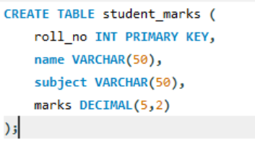
OUTPUT-
QUERY2-
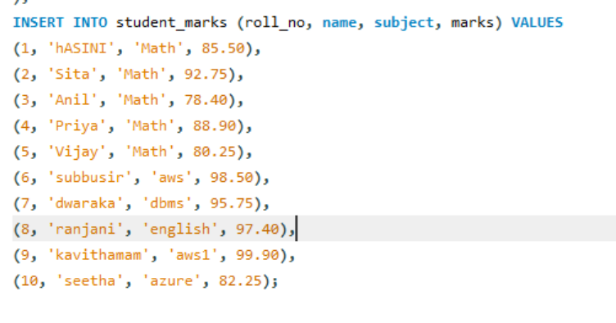
OUTPUT-
QUERY3-

OUTPUT-
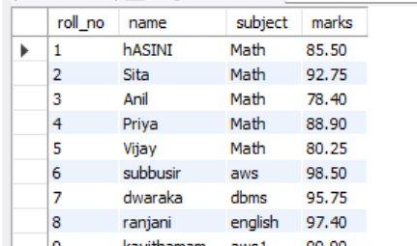
QUERY4-
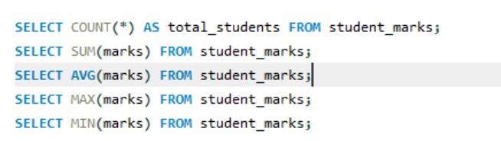
OUTPUT-
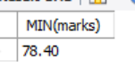
QUERY5-
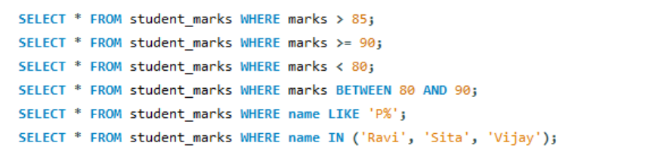
OUTPUT-
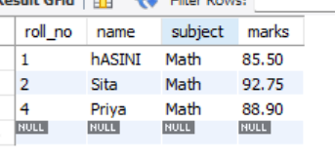
QUERY6-
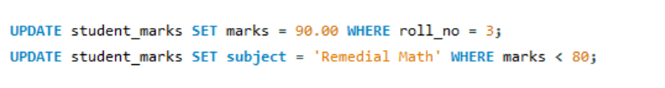
OUTPUT-
QUERY7-

OUTPUT-
QUERY8-

OUTPUT-
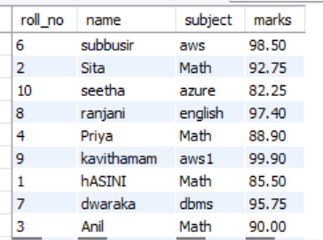
QUERY9-
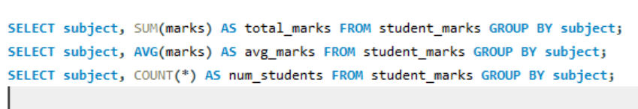
OUTPUT-
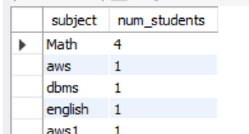
QUERY10-
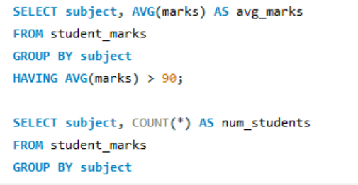
OUTPUT-
